Android Leave Management System

ABSTRACT

The main objective of this project is to maintain the attendance for the employees and to perform the leave requisition forms, electronically. Each and every employee uses their Smart Card to enter the door. As once the employee scratch his/her card their attendance is to be detected. The users or employees from anywhere can access the Intranet and request their Leave and Permission. This saves time and improves the efficiency of employees in the Concern, CONCORD IT Services. Every employee had their ID cum Smart Card to enter the doors. Once he/she enters the door, their Login time is been detected. All authorized users have unique User-id. Using the User-id and the employee can login. The administrator can view the user’s details. Only authorized users or employees can logon and request the leave or permission. The administrator has full rights to access the database. The employee details can be viewed or deleted only by the administrator. The employees can be created or deleted or modified only by the administrator. The Manager can send mails to employees. The manager can view or delete the requisition details, which are entered by the employees.

EXISTING SYSTEM

The existing leave Management system has many shortcomings associated with it. Manually administered leave management programs are costly to manage, difficult to track and often result in errors. Automated LMS can drastically change this scenario.
Employers are therefore always looking for paperless, effective solutions that reduce or eliminate the margin of error in leave benefits calculations.
PROPOSED SYSTEM

Leave management encompasses the processes employees use to request time away from work and manager use to grant or deny leave based on organization policies. Smooth automation of existing manual systems based on an organization's unique business processes. Easily accessible and consolidated leave information for analysis and reporting. Workflow communicates with the leave database to display employee leave history during login, Allows for leave request routing based on hierarchy and user details specified in the Active Directory. The workflow can be enabled to build in escalation in case of unavailable manager or if more than one approval is required. Once a manager confirms an employee's leave status and updates the leave balance, the LMS cycle is completed.
LMS Workflow:
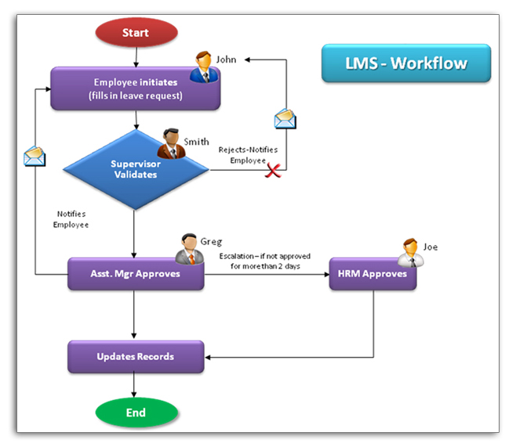
MODULE DESCRIPTION

- Admin Module
- Manger Module
- Employee Module

Admin Module

- Admin will perform all the function that manager and employee can perform.
- Admin view the employee attendance deduction, manager details, and employee details.
- They can edit and view the employee leave record.
- Admin will maintain the entire database according to leave management
System for MNC

Manager Module
- View Leave Request: Managers can view multiple leave requests at the same time for planning purposes for their respective department.
- Approval of Leave Request: Managers can approve leave request after checking/matching the leave availability, history etc.
- View Leave Balances: Managers can view leave balances of employees of the concerned department.
- Cancel Leave Request: Manager can even cancel future leave request even after approved.
- View Employee Response: Manager can view the employee response after sending approved or rejected reply.

Employee Module

- Enter Leave Request: Employee can enter leave request for time-off using a leave request form.
- Request Status: Each Leave Request can be viewed in real time.
- Manager Response: Employee can view response from manager for the requested leave to be either approved or rejected according to leave history.
- Leave Cancellation: Employee can cancel leave after manger response for the employee leave. Employee will send message to manager to cancel leave requisition.

SYSTEM REQUIREMENTS:
HARDWARE REQUIREMENTS:
- System : Pentium IV 2.4 GHz.
- Hard Disk : 40 GB.
- Floppy Drive : 1.44 Mb.
- Monitor : 15 VGA Colour.
- Mouse : Logitech.
- Ram : 512 Mb.
SOFTWARE REQUIREMENTS:
- Operating system : Windows XP.
- Coding Language : Java 1.6
- Tool Kit : Android 2.2
- IDE : Eclipse

