Can You Trust Online Ratings? A Mutual Reinforcement Model for Trust worthy Online Rating Systems

Abstract:

The average of customer ratings on a product, which we call a reputation, is one of the key factors in online purchasing decisions. There is, however, no guarantee of the trustworthiness of a reputation since it can be manipulated rather easily. In this paper, we define false reputation as the problem of a reputation being manipulated by unfair ratings and design a general framework that provides trustworthy reputations. For this purpose, we propose Trust-reputation, an algorithm that iteratively adjusts a reputation based on the confidence of customer ratings. We also show the effectiveness of Trust-reputation through extensive experiments in comparisons to state-of-the-art approaches.

Existing system:

The most common way to aggregate ratings is to use the average (i.e., to assign the same weight to each rating), which may result in a false reputation. For example, a group of abusers may inflate or deflate the overall rating of a targeted product. The existing strategies avoid a false reputation by detecting and eliminating abusers. However, abusers cannot always be detected, and it is possible that normal users may be regarded as abusers. Consequently, existing strategies can exclude the ratings of normal users or allow the ratings of abusers to be included in the calculation of a reputation. existing strategies against shilling attacks; all are trying to prevent the manipulation of ratings by abusers. The classification algorithms for detecting shilling attacks, however, may face situations where malicious users cannot be detected and/or where normal users are considered as malicious. As a result, there may be instances when a reputation is calculated without the ratings of normal users or including the ratings of malicious users.

Proposed system:
The proposed framework does not require clustering or classification, both of which necessitate considerable learning time. Though TRUE-REPUTATION does not require any learning steps when solving a false reputation, extensive experiments show that TRUE-REPUTATION provides more trustworthy reputations than do algorithms based on clustering or classification. The contributions of this paper are as follows. First, we have defined false reputation and categorized various real-life scenarios in which a false reputation can occur. The categorization of the false-reputation scenarios helps us design experimental scenarios similar to real-life situations. Second, we have proposed a general framework to address a false reputation by quantifying the level of confidence of a rating. The framework includes TRUE-REPUTATION, an algorithm that iteratively adjusts the reputation based on the confidence of customer ratings. Third, we have verified the superiority of TRUE-REPUTATION by comparing it with machine-learningbased algorithms through extensive experiments.

Problem statement:

This paper defines the false reputation problem in online rating systems and categorizes various real-life situations in which a false reputation may occur. The understanding of why and when a false reputation occurs helps us establish experimental situations. In order to solve the false reputation problem, we proposed a general framework that quantifies the confidence of a rating based on activity, objectivity, and consistency. The framework includes TRUE-REPUTATION, an algorithm that iteratively adjusts the reputation based on the confidence of user ratings. Through extensive experiments, we showed that TRUE-REPUTATION can reduce the influence of various RAs. We also showed that TRUE-REPUTATION is superior to the existing approaches that use machine-learning algorithms such as clustering and classification to solve the false reputation problem.

Future Work:

In a further study, we plan to develop an approach to accurately separate an item score and a seller score from a user rating. Separating the true reputation of items and that of sellers would enable customers to judge items and sellers independently.

Implementation Of Modules:

False-Reputation Module:

In an online rating system, it is almost impossible to obtain the ground-truth data because there is no way of knowing which users have caused a false reputation in a real-life database. We artificially establish various situations in which a false reputation may occur and test the performance of the proposed algorithm in these situations. In order to claim that the generated situations are likely to occur in real-life online rating systems, we list various scenarios involving a false reputation and categorize them according to the types of user and situations. In this section, we define dangerous users who cause a false reputation and dangerous situations leading to a false reputation. Using the definitions of dangerous users and dangerous situations,

- Dangerous users.
- Dangerous situations.
- False Reputation Scenarios.

TABLE I
FALSE-REPUTATION SCENARIOS

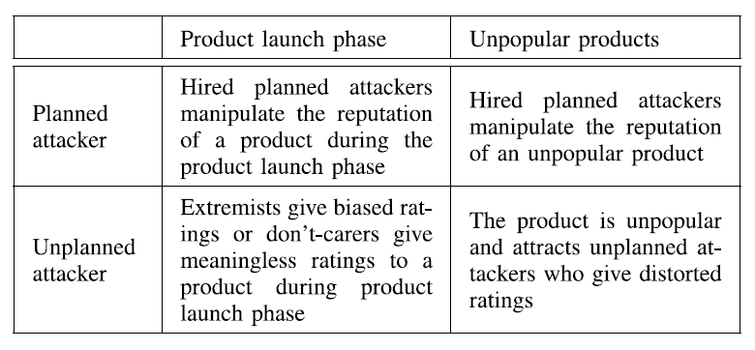

Robustness:

In order to enhance the robustness of recommendation systems, it is imperative to develop detection methods against shilling attacks. Major research in shilling attack detection falls into three categories:
1) classifying shilling attacks according to different types of attacks.
2) extracting attributes that represent the characteristics of the shilling attacks and quantifying the attributes
3) developing robust classification algorithms based on the quantified attributes used to detect shilling attacks
Strategies for improving the robustness of multi agent systems can be classified into two categories. The first group of strategies is based on the principle of majority rule. Considering the collection of majority opinions (more than half the opinions) as fair, this group of strategies excludes the collection of minority opinions, viewed as biased, when calculating the reputation.

Unfair Ratings:

The trustworthiness of a reputation can be achieved when a large number of buyers take part in ratings with honesty .If some users intentionally give unfair ratings to a product, especially when few users have participated, the reputation of the product could easily be manipulated. In this paper, we define false reputation as the problem of a reputation being manipulated by unfair ratings. In the case of a newly-launched product, for example, a company may hire people in the early stages of promotion to provide high ratings for the product. In this case, a false reputation adversely affects the decision making of potential buyers of the product.
a reputation based on the confidence scores of all ratings, the proposed algorithm calculates the reputation without the risk of omitting ratings by normal users while reducing the influence of unfair ratings by abusers. We call this algorithm, which solves the false reputation problem by computing the true reputation, TRUE-REPUTATION. Our framework for online rating systems and the existing strategies in multiagent systems serve the same purpose in that they are trying to address unfair ratings by abusers.

Buyer Modules:
Numerous studies have been conducted to improve the trustworthiness of online shopping malls by detecting abusers who have participated in the rating system for the sole purpose of manipulating the information provided to potential buyers (e.g., reputations of sellers and recommended items). Especially in the fields of multiagent and recommendation systems, various strategies have been proposed to handle abusers who attack the vulnerability of the system. In online rating systems, on the other hand, a buyer can give only a single rating per item. Thus, the relationship between buyers and items is significantly different from the relationship between buyers and sellers; as such, the graph structure of an online rating system is very different from that of a multiagent system. This paper uses an approach that considers the relation between buyers and items.

Conclusion:

This paper defines the false reputation problem in online rating systems and categorizes various real-life situations in which a false reputation may occur. The understanding of why and when a false reputation occurs helps us establish experimental situations. In order to solve the false reputation problem, we proposed a general framework that quantifies the confidence of a rating based on activity, objectivity, and consistency. The framework includes TRUE-REPUTATION, an algorithm that iteratively adjusts the reputation based on the confidence of user ratings. Through extensive experiments, we showed that TRUE-REPUTATION can reduce the influence of various RAs. We also showed that TRUE-REPUTATION is superior to the existing approaches that use machine-learning algorithms such as clustering and classification to solve the false reputation problem. There are more factors (other than those addressed in this paper) known to be elemental in assessing the trust of users in the field of social and behavioral sciences. We plan to study how to incorporate them into our model to compute the reputation of items more accurately. In the e-market place such as Amazon.com and eBay.com, buyers give ratings on items they have purchased. We note, however, that the rating given by a buyer indicates the degree of his satisfaction not only with the item (e.g., the quality) but also with its seller (e.g., the promptness of delivery).

